Use-Case Realization Report (Analysis)
Display Survey Info

Issue 1.0
Revision History
Date | Issue | Description | Author
01/Aug/09 | 1.0 | First Issue | Thomas Yap

Table of Contents
1. Brief Description 4
2. Flow of Events 4
2.1 Standard Flow 4
2.1.1 Display Survey Info 4
2.2 Exception 4
3. Interaction Diagrams 5
3.1 Collaboration Diagram for Display Survey Info 5
4. Participating Objects 5
5. Class Diagrams 6
5.1 Class Diagram for Display Survey Info 6
6. Derived Requirements 6

Use-Case Realization Report
Display Survey Info

Brief Description
This use case enables the controller to display survey info retrieve from Survey Pool. It involves displaying the menu and form and search by searchstrings.

Flow of Events
The standard flow of events for this use case and any exceptions are described in the following subsections. The events are described in terms of Actors and Analysis Objects.

Standard Flow
This use case covers the Survey Maintenance - Display Survey Info. The standard flow of these events are described below.

Display Survey Info
The running of the application is shown in section 3.1. The flow of event is as follow:

- When the application start, the first operation to be performed is the startup operation of the main controller. This operation will create all the control objects and the entity objects necessary for operation Update Survey:
  - The control object created is: Survey Controller
  - The entity objects create are: Survey and Transaction Record

- The main controller will start the main function menu:
  - To start Display SURVEY Info, there are two ways. One, through operation FormDisplaySurvey activated by SURVEY Controller to display a SURVEY list form. Two, through UpdateSurvey operation
  - Portal Admin will see all information on the FormDisplaySURVEY Use Case Display SURVEY List will retrieve a title list of SURVEY for Portal Admin. This list will contain all information on SURVEY. If the user chooses to do edition, then the admin will click on the SURVEY name which is linked to use case UpdateSURVEY.

- Step 2 will be repeated until all searches are completed. Then controller will terminate the application by issuing operation close.

Exception
None.

Interaction Diagrams

Collaboration Diagram for Display Survey Info
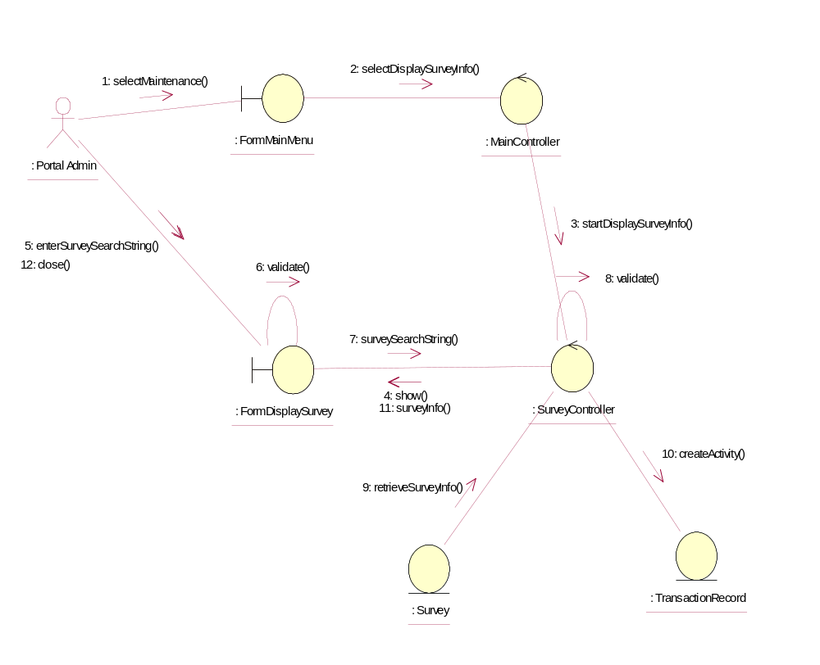

Participating Objects
: FormDisplaySurvey
This object is the interface for keying Surveys details.

: FormMainMenu
This is the main menu at the beginning of the application from where it can access the Survey Maintenance - Display Survey Info operation.

: MainController
This is the main controller that control the whole system.

: Portal Admin
This is the only actor that authorized to perform operation Survey Maintenance - Display Survey Info.

: Survey
This entity stores all the exam or exercise Surveys.

: SurveyController
This is the controller for Survey Maintenance. It creates and activates FormDisplaySurvey interface and Survey entity object.

: TransactionRecord
This is the entity object that created for transaction log and audit trail.

Class Diagrams

Class Diagram for Display Survey Info
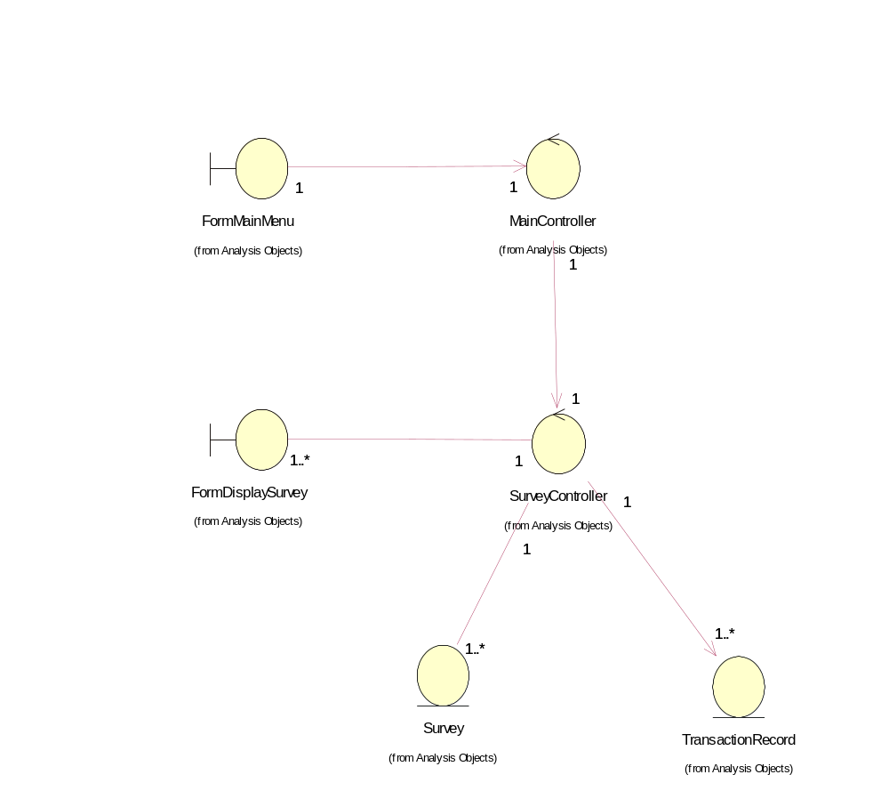

Derived Requirements
The FormMainMenu and FormDisplaySurvey Interface should have the format specified in User Requirements Specification for Content Management Portal.

